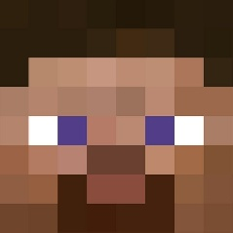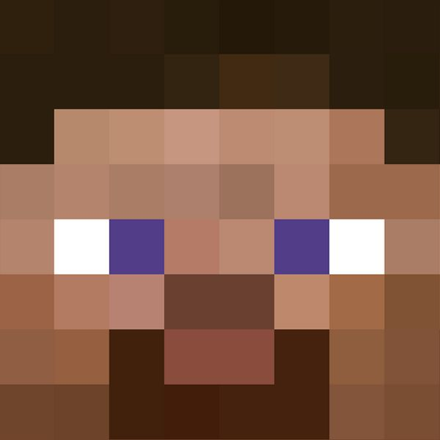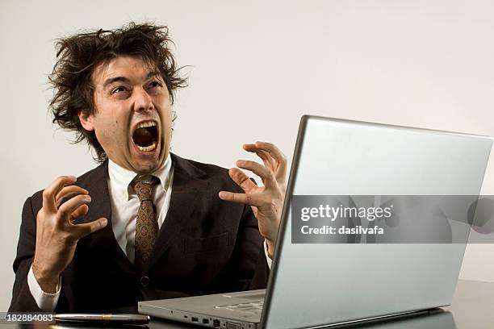INSTALLING BEHAVIOR PACKS



A STEP-BY-STEP INSTRUCTION PROCESS 😊

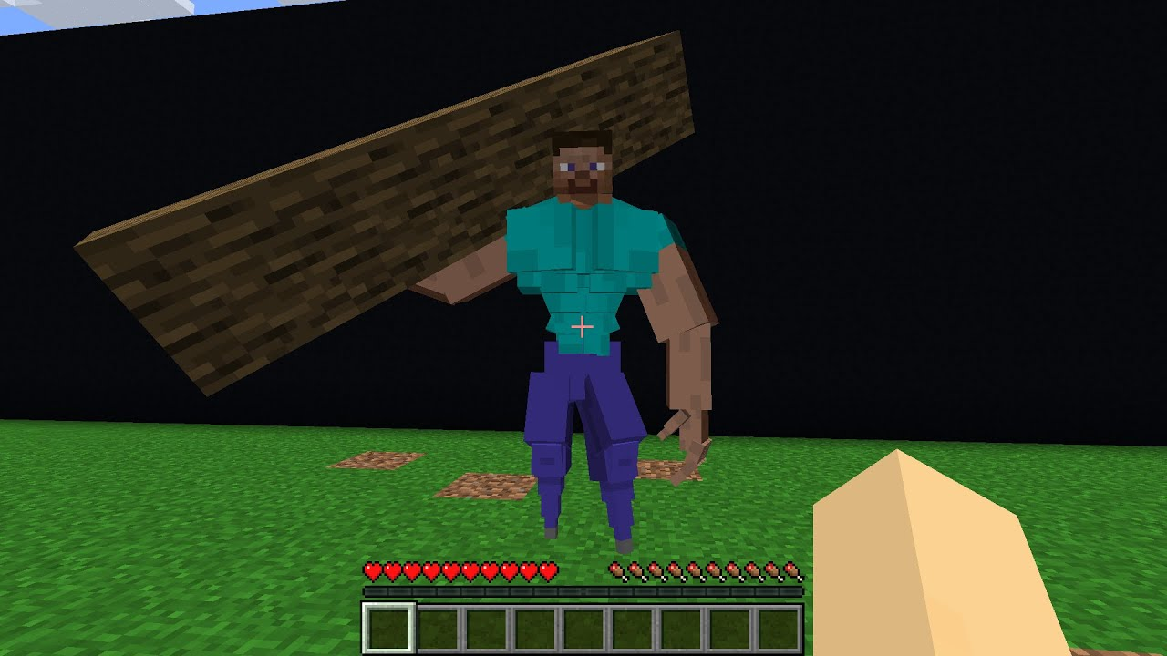

This will be **you** if you learn to install behaviour packs…

Table of Contents

STEP 1: Finding the Pack 2

STEP 2: Navigating files 3

Step 3: Adding Packs 4

STEP 3a: Adding Behaviour Pack 4

STEP 3b: Adding Resource Pack 6

STEP 4: Applying the pack in game 7

STEP 4a: Applying Behaviour Pack: 8

STEP 4b: Applying Resource Pack: 9

STEP 5: Have fun! 11

Pack Stacking 11

Potential Bugs 13

1# Pack does not appear in the menu 13

2# Pink and Black chequered pattern 13

3# Dirt block with ‘?’ 13

4# Chunk Deloading Visual Glitch 14

5# Shaders not shading 14

6#??? 16

# STEP 1: Finding the Pack

Link to GitHub (just a code hosting website)

<https://github.com/badideainc/Chaos-Pack>

<https://github.com/Cubeir/Vanilla-RTX>

**(NOTE: double check I have uploaded the updated pack to GitHub, else you will just download the same pack again)**

*(Page should look something like this)*

Ignore everything on the page except the big green button (it’s all just a bunch of boring nerd junk).

Press the green button and then press ‘Download ZIP’ on the newly opened menu.

# STEP 2: Navigating files

Open file explorer and move to your ‘Downloads’

Open the file, inside there should a single folder. Open the folder (**NOTE:** You can unzip the file if you want to but it’s largely unnecessary).

*(The required packs are within this file)*

Inside, there should be three files (two folders and a text document). Ignore the text document as you will not need it (you can read it if you want, it’s literally a text file).

**BP:** Outer file for the behaviour pack

**RP:** Outer file for the resource pack

# Step 3: Adding Packs

## STEP 3a: Adding Behaviour Pack

Enter the BP file. Inside will be a folder labelled **‘Chaos Pack’** (This is the folder we need)

Right click and copy this folder (This is easier than dragging the folder)

Next find the shortcut file path **‘com.mojang’** and press on it (This will take you into the game files)

The file path should take you to something resembling this:

Enter the **‘behavior_packs’** folder.

Right click and paste the folder into the folder

*(****NOTE:*** *If the folder is already present, it will ask you if you want to overwrite (replace) it, click yes)*

## STEP 3b: Adding Resource Pack

Enter the RP folder. Inside will be a folder labelled **‘Chaos Pack’** (This is the folder we need)

Right click and copy this folder (This is easier than dragging the folder)

Next find the shortcut file path **‘com.mojang’** and press on it (This will take you into the game files)

The file path should take you to something resembling this:

Enter the **‘resource_packs’** folder.

Right click and paste the folder into the folder

*(****NOTE:*** *If the folder is already present, it will ask you if you want to overwrite (replace) it, click yes)*

# STEP 4: Applying the pack in game

Lauch Minecraft via the launcher (obviously). Get to this screen on your world.

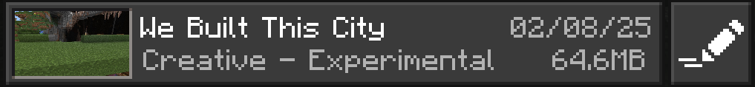

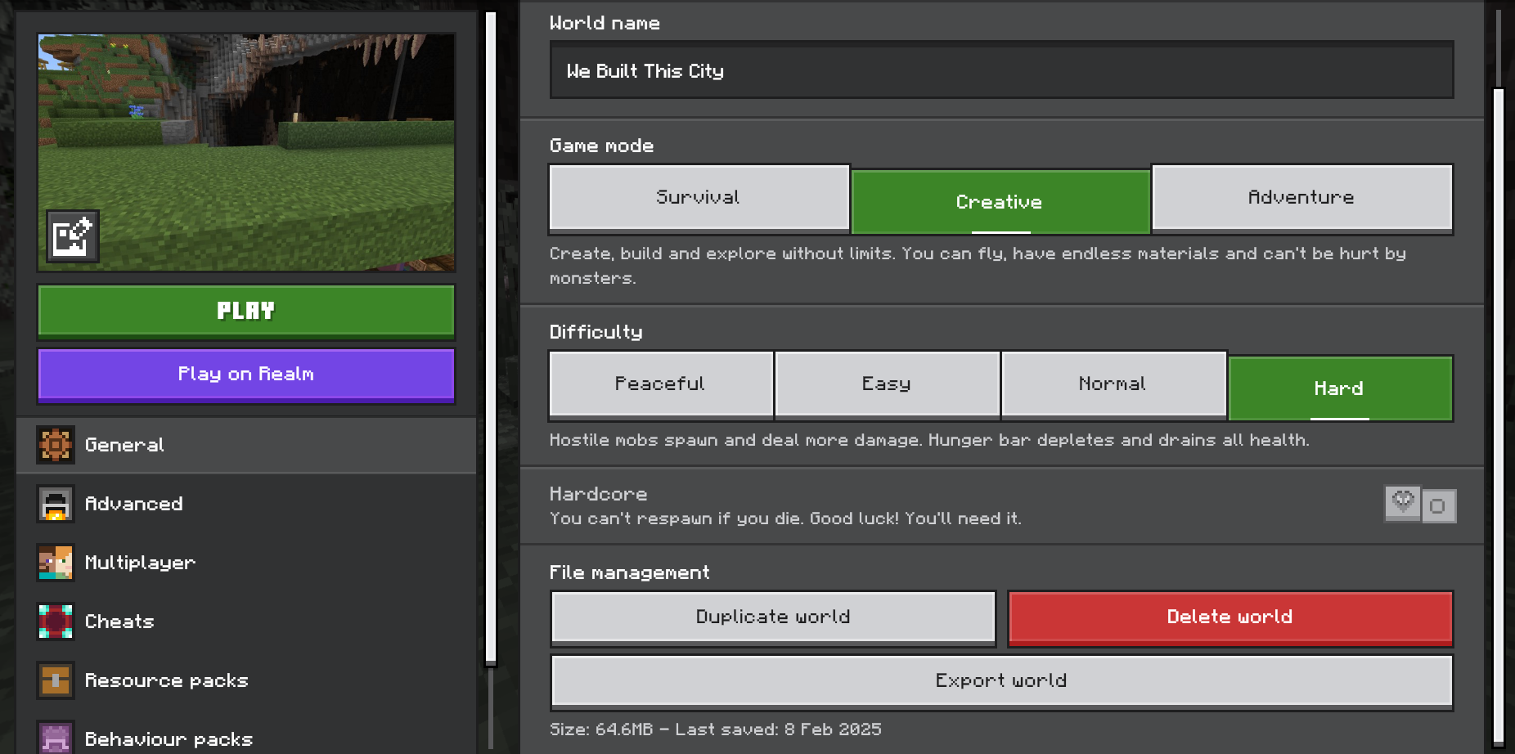

## STEP 4a: Applying Behaviour Pack:

Select the **‘behaviour packs’** tab.

If it is there… Good Job!



Press activate and the behaviour pack will be applied.

## STEP 4b: Applying Resource Pack:

The resource pack used to activate automatically, but since 1.21 it only happens sometimes (probably a bug). Check the **‘resource pack’** tab.

Press on the **‘Owned’** drop-down menu

If it is there… Good Job x2!



Press activate and the behaviour pack will be applied.

# STEP 5: Have fun!

Join your world, and check everything has loaded correctly!

# Cursed Minecraft Images (@CursedMCImages_) / XAren't mods fun? : r/MinecraftMemesPack Stacking

The order of packs matters. The higher up pack will overwrite anything it shares with the lower packs.

*With* ***‘World Pack’*** *on top, grey wool and glass appear as this…*

However, if **‘Chaos Pack’** is on top…

Glass reverts to the **‘Chaos Pack’** texture, but grey wool does not because there is no specific override in that pack.

# Potential Bugs

## 1# Pack does not appear in the menu

If this occurs it is most likely because the folder is not pasted in the correct location. If the BP or RP outer folder is also pasted into the correct location it will not appear as exact file layout is required.

## 2# Pink and Black chequered pattern

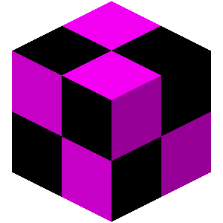If a block or entity appears like this, something is wrong with the texture formatting. This is likely a mistake on my side, and I will need to fix it on my end.

(Most likely not a problem on your end)

## 3# Dirt block with ‘?’

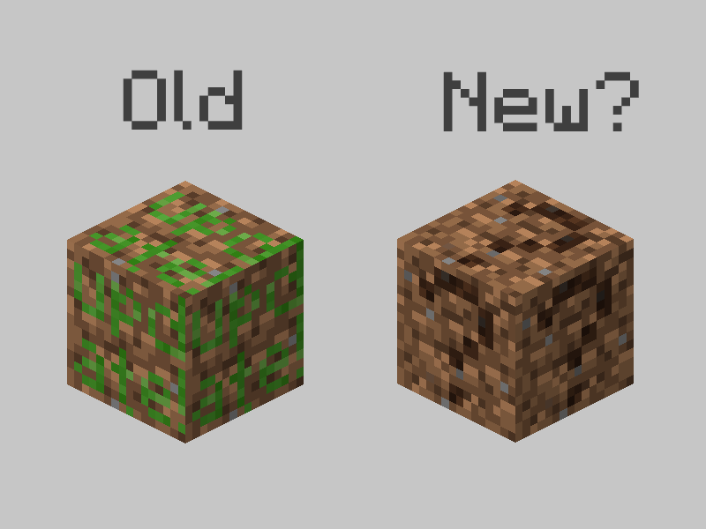

If a block appears like this, the block is undefined. This is also likely a mistake on my side, so I will need to fix it on my end.

(Most likely not a problem on your end)

## 4# Chunk Deloading Visual Glitch

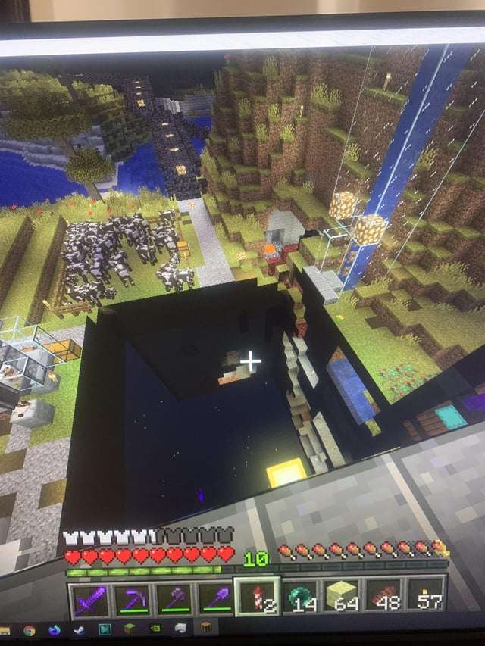If a block has an error, and has been placed in the world, the chunk it is in will not load.

This will be fixed when the block itself is fixed.

This is also probably a mistake on my end, so will also have to fix on my end.

(Most likely not a problem on your end)

## 5# Shaders not shading

There are multiple graphic modes in visual settings to turn on ray tracing. This should be on by default but might change with an update.

If this occurs simply set it back to ray tracing (minor lag included)

## 6#???

